**Cylinder and Order Management System (COMS)**

**Prototype Study Report**

|  |  |
| --- | --- |
| Filing Reference : | GG/COMS/MR.2 |
| Document Title : | Prototype Study Report |
| Version : | 1.0 |
| Prepared By : | Koh Ming Jin |
| Date Created : | Monday, August 1st, 2011 |

|  |  |  |
| --- | --- | --- |
| Approved By : |  |  |
|  | Tran Ba Tien | Date |
|  | Project Manager | 10 Aug 2011 |
|  |  |  |
|  |  |  |
|  |  |  |

|  |  |
| --- | --- |
| **2011 [Hoang Kim joint stock Company].**  **The information contained in this document is the property of [Hoang Kim joint stock Company]. The contents must not be reproduced, wholly or in part, for purposes other than for which it has been supplied, without the prior permission of [Hoang Kim joint stock Company], or, if it has been furnished under contract to another party, as expressly authorised under that contract. [Hoang Kim joint stock Company] shall not be liable for any errors or omissions.** |  |

Document Reference: GG/COMS/MR.2

|  |  |  |  |  |
| --- | --- | --- | --- | --- |
| **Version** | **Date** | **Author** | **Authorised by** | **Date** |
| 1.0 | 01/08/2011 | Koh Ming Jin | Tran Ba Tien | 10/08/2011 |
|  |  |  |  |  |
|  |  |  |  |  |
|  |  |  |  |  |
|  |  |  |  |  |
|  |  |  |  |  |
|  |  |  |  |  |

**Distribution :**

|  |  |  |
| --- | --- | --- |
| **Name** | **Department** | **Organisation** |
| Tran Ba Tien | SE18-Team2S | MTech(ISS) |
| Alvin Chang | SE18-Team2S | MTech(ISS) |
| Maung Tin Kyaw Oo | SE18-Team2S | MTech(ISS) |
| Koh Ming Jin | SE18-Team2S | MTech(ISS) |
| Phyo Phyo Lwin | SE18-Team2S | MTech(ISS) |
| Junaith | SE18-Team2S | MTech(ISS) |

Table of Contents

1. INTRODUCTION 4

1.1. Purpose 4

1.2. Audience 5

1.3. Organization 5

1.4. References 5

2. PROTOTYPE APPROACH 6

3. IMPLEMENTATION STRATEGY 6

3.1. Prototype Design Considerations 6

3.2. Conceptual Prototype Design 8

3.2.1 Client Environment (Presentation Layer) 8

3.2.2 Business Logic Environment (Business Logic Layer) 8

3.2.3 Data Access Environment (Data Access Layer) 9

3.3 Prototype System Requirements 9

3.4 Identified Use Cases for Technical Feasibility Verification 9

3.5 User Interfaces Prototype for Usability Verification 10

4. RESULTS AND FINDINGS 15

5. CONLUSION 16

# INTRODUCTION

Hoang Kim (HK) Joint Stock Company is one of the leading providers of printing cylinders in Vietnam. They have engaged our project team to develop a flexible integrated system which would allow them to manage the key manufacturing processes, benchmark employees’ performance, generate daily business operation reports and add in new features to the system if required. In addition, HK also intends to make their application component reusable and to allow exchange of data between different applications or platforms in the near future.

The project team has come out with a preliminary architecture proposal after having a detailed study and analysis of the above mentioned requirements and HK’s use cases. The journey from concept to final system is typically a long road riddled with hidden obstacles and unforeseen turns. Hence, the project team has decided to build a quick prototype of their proposed preliminary architecture, to help to smooth the development path as well as present some other benefits.

## Purpose

The purpose of this document is to record the findings and results from the prototype development for the proposed architecture and to document the feasibility of the technology used in this project. The objectives of developing prototype are as follows:

* To test the feasibility of the proposed architecture
* To address both the foreseen and the unforeseen technical challenges of our proposed design and reduce the number issues when the project team moves to the final deployed solution.
* To brainstorm on how to design a task-centered user friendly interface
* To quickly conduct several different implementations of the features and benchmark the resulting performance to analyze the trade-offs of each approach. This can save time and ensure correct design decisions.
* To demonstrate the functionalities to solidify requirements for the final design.
* To facilitate the conduct of UI design reviews with the users
* To refine the planned implementation effort required

## Audience

The intended reader of this Prototype Study Report is the project team to:

1. Provide them with an overview of the technical feasibility and challenges

2. Identify the potential problems that may arise during the design and implementation phases

3. To finalize the development environment of the project.

## Organization

The organization of this document is as follow:

* Section 2: Presents the approach used during the development of prototype.
* Section 3: Provides the Implementation Strategy used in the prototype development.
* Section 4: Summarizes the results and findings from the prototype development.
* Section 5: Conclusion of the results and findings

## References

To fully understand the background to this project, the reader should also be familiar with the COMS Project Plan (reference GG/COMS/MP.2/v1).

# PROTOTYPE APPROACH

The prototyping approach which the project team had adopted was a throwaway/rapid prototyping. The key intention was to verify the User Interface requirements and to assess the technical feasibility of the initial proposed solution.

The prototyping process was initiated by two meetings, one with the customer and one with the project team. The purpose and the intended use situation of the prototype were presented for both groups. The purpose of the prototyping process was also explained, along with a brief description of the principles of prototyping. In addition, the customer, who are in Vietnam, was also encouraged to give an immediate response by e-mail when they see any UI issues with the prototype or when they have any ideas relating to it. A mutual understanding and agreement of the aim of the project were developed based on discussions regarding our respective expectations.

# IMPLEMENTATION STRATEGY

The key prototyping objectives were explored by illuminating two key aspects of the prototype system: Technical Feasibility and Usability.

After studying the customer’s requirements, one of the main challenges which the project team faced, was to allow design of the cylinder work flows using a simple “drag and drop” interface console. This interface console shall enable users to drag and drop the appropriate manufacturing steps and link them up to form a cylinder workflow process. In consideration of the performance requirement, the project team had proposed to use a thick client solution to implement the workflow management. In addition, to reduce the software maintenance effort, the customer would like the rest of the applications to be web pages, instead of thick client. Hence, for the exploration of the technical feasibility study of the prototype system, the project team would like to verify the proposed architecture design using both thick and thin clients.

Furthermore, this prototype served as the point of departure for discussion with the customers. The project team had implemented the key User Interfaces and showed them to the customers via email. Based on discussion with the customers through the email or phone, the prototype system was gradually incremented or modified.

## 3.1. Prototype Design Considerations

The ability and agility to develop and deploy new application services are keys to success in today’s competitive information economy. Therefore, it is important to define the communications and integration standards to support a variety of clients, which can contribute to both responsiveness and flexibility of the production system. The following list contains some of the key design drivers which were considered for the prototype design:

1. **Multi-Tiers Architecture**

The concept of multi-tiers provides a convenient way to group different classes of architecture. Choosing the right architecture design will provide a model for developers to create a flexible and reusable application. By breaking up an application into tiers, developers only have to modify or add a specific layer, rather than have to rewrite the entire application over.

1. **Model-View-Controller Framework**

MVC is an object-oriented framework and design pattern for building applications and reusable components. An application will be separated into three key portions: the model, the view and the controller, where input is governed by the controller, processing by the model and output by the view. Model view controller paradigm decouples these three different components (data, business logic, presentation) of a system and reduces hard coded association and coupling. Thinking about a system along this architectural paradigm makes understanding of a system a lot simpler. It will advocate the concept of encapsulating data together with its processing (model) and isolating it from the manipulation (controller) and presentation (view) portion.

1. **Reusability**

Although computing power and network bandwidth had increased dramatically in recent years, the design and implementation of distributed applications remain expensive and error pone. Therefore, the goal is to provide a software architecture for the application, which has common components (required by all developers), optional components (required by only some developers), and variant components (i.e. different versions of which are required by different developers)

1. **Flexibility**

The newly adopted architecture should allow considerable customizability and flexibility so that highly configurable software systems can be constructed as required. This will eventually enable the new system to adapt, modify or being extended accordingly to new demands.

1. **Security**

In cases where users need to access information, security mechanisms need to provide and maintain high security (and user confidence) while remaining as unobtrusive and transparent as possible.

## 3.2. Conceptual Prototype Design

J2EE and .NET offer pretty much the same laundry of list of features, albeit in different ways. While there are pros and cons for choosing either framework, only two are considered significant in this implementation.

* Java is not just a platform, but a language, while .NET is language independent. Adopting .NET does not force you to adopt a single or even specific language. .NET can even support the Java language, and J# is very close to Java.
* .NET can coexist with and even integrate with existing Win32 code.

Therefore, after considering all the key design drivers to meet the user requirements, the conceptual architecture design is a 3-tier service-oriented architecture using .NET C# programming language. The architecture has adopted a communication model which is based on the Web Services to provide the service-oriented solution.



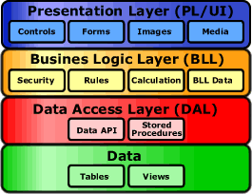

## 3.2.1 Client Environment (Presentation Layer)

The proposed client environment will consist of both thick and thin client applications running in remote terminals to meet the customer’s requirements. The proposed thick client application, which was developed using the C# .NET programming language, will be used mainly to design the cylinder manufacturing work flows. On the other hand, the thin client application, which will be accessed via the Internet explorers, will be used in the updating and reporting of the cylinder manufacturing process.

## 3.2.2 Business Logic Environment (Business Logic Layer)

Microsoft .Net framework is chosen for the implementation of the business logic layer and the access mechanism to the data services. The proposed business logic environment will consist of an IIS web server, which will store all the business logics for the cylinder management applications. The application components will be used to enforce business rules, such as business algorithms, methods, regulations and data rules, which are designed to keep the data structures consistent within either specific or multiple databases. The business components can be used by all applications as they will not be tied to a specific client machine.

## 3.2.3 Data Access Environment (Data Access Layer)

The proposed data access environment will interact with persistent data stored in a database. This layer will consist of data access components to aid in resource sharing and to allow clients to query or update via the business logic tier.

## 3.3 Prototype System Requirements

The following list contains the list of hardware and software components used for the prototype system.

**Hardware**

* Laptop
  + Processor: Pentium(R) Intel Core® 2 Duo 2.6 GHz
  + RAM: 2 GB of RAM
  + Hard Drive Space: 8 GB of uncompressed hard disk space
* Barcode scanner

**Software**

* Operating System: Windows Vista®
* Operating System: Windows® 7
* Visual Studio 2008
* Microsoft IIS Webserver
* Microsoft .Net Framework 4.0
* Internet/ Mozilla Explorer 7.0
* MSSQL Database

## 3.4 Identified Use Cases for Technical Feasibility Verification

The identified use cases to verify the technical feasibility are “Update Cylinder Status” & “Manage Workflow”. The reasons for choosing these use cases were because they involve the key processes of the entire production system and the project team was unsure and would like to find out about the exact implementation of these use cases, especially the use cases which involve the thick client portion (i.e. Manage Workflow). The table shows the verification objective of the respective use cases.

|  |  |  |  |
| --- | --- | --- | --- |
| **Use Case** | **Types** | **Capability** | **Objective** |
| Manage Workflow | Thick client | * To allow users to design cylinder workflows using a simple “drag and drop” interface. * To enable the user to drag and drop the appropriate manufacturing steps and link them up to form a cylinder workflow. | * To verify if the thick client can access the back-end information via the web service. * To monitor the performance * To estimate the development effort |
| Update Cylinder Status | Web client | * To generate and display Cylinder manufacturing information. * To enable users to update cylinder status in the production line. | * To estimate the development effort * To confirm with users if the operation process is able to meet their expectation |

## 3.5 User Interfaces Prototype for Usability Verification

The following shows the key User Interfaces which were developed and shown to the customers for comments. The customers are satisfied with the simple yet user friendly User Interfaces and allow the PMT to proceed to the next stage (design stage).

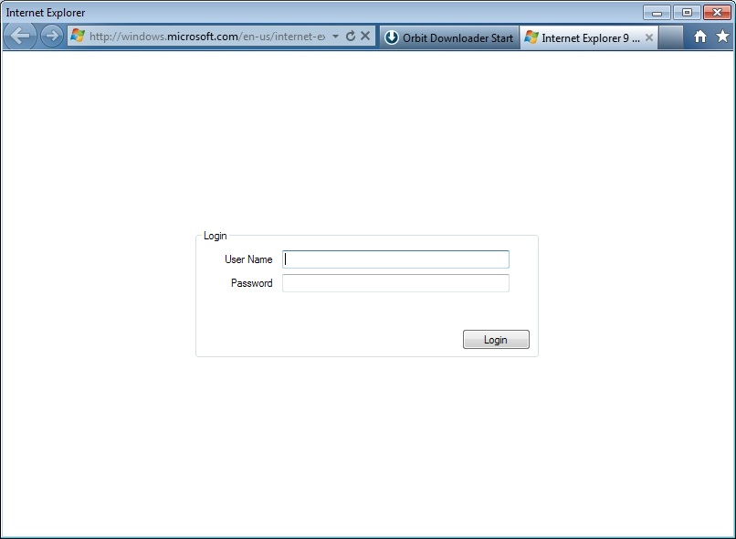

Figure 1: Login Page

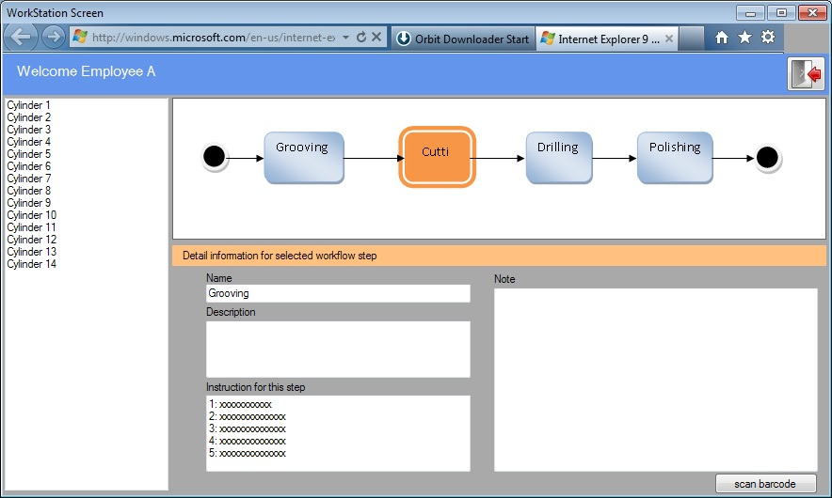

Figure 2.1: Worker Page

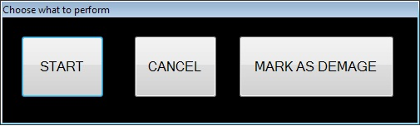

Figure 2.2: Barcode Scanning Page

THE FOLLOWING PAGES REQUIRE APPROPRIATE ACCESS RIGHTS:

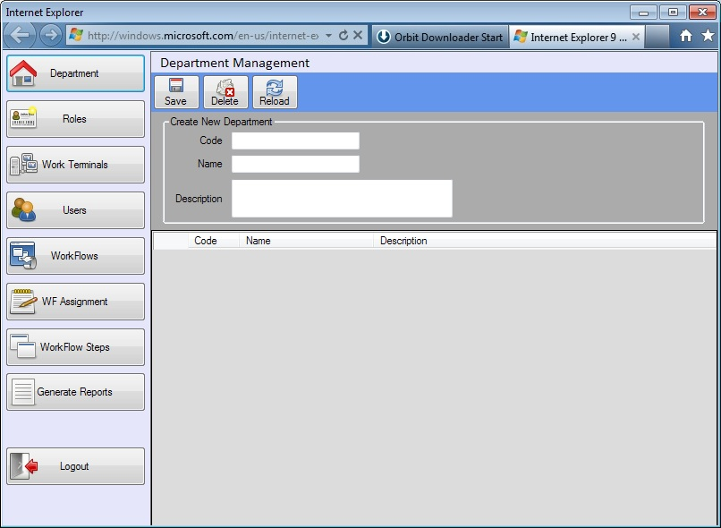

Sales Order

Figure 3.1: Department Page

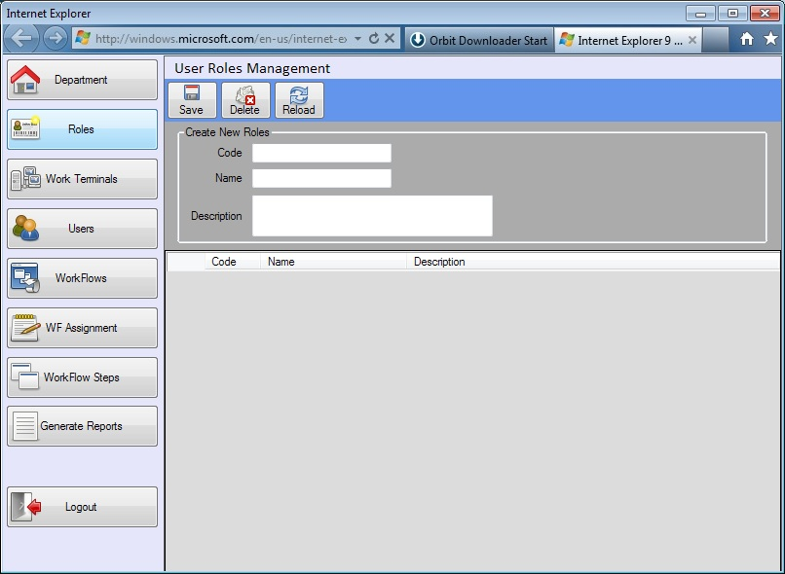

Sales Order

Sales Order

Figure 3.2: Roles Page

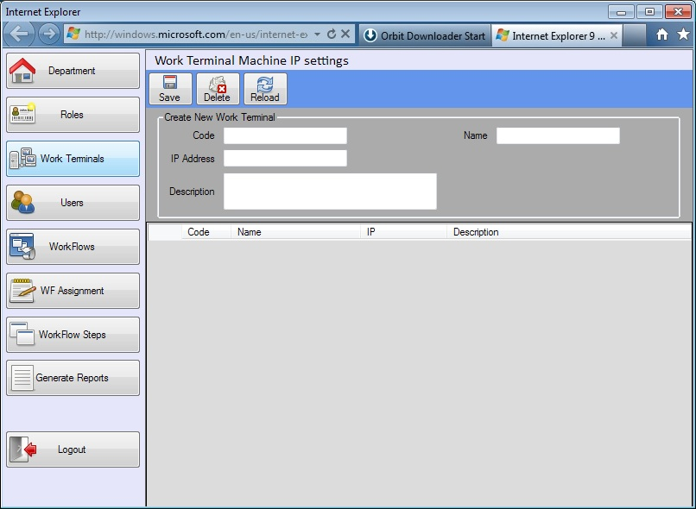

Sales Order

Figure 3.3: Terminal Page

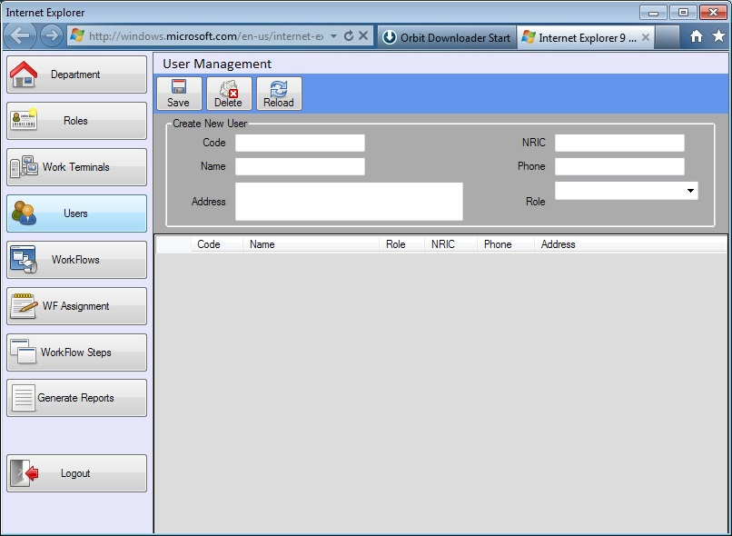

Sales Order

Figure 3.4: User Page

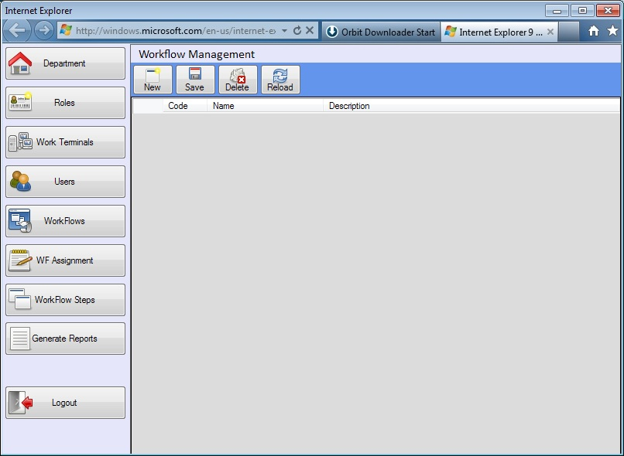

Sales Order

Figure 3.5.1: Workflow Page

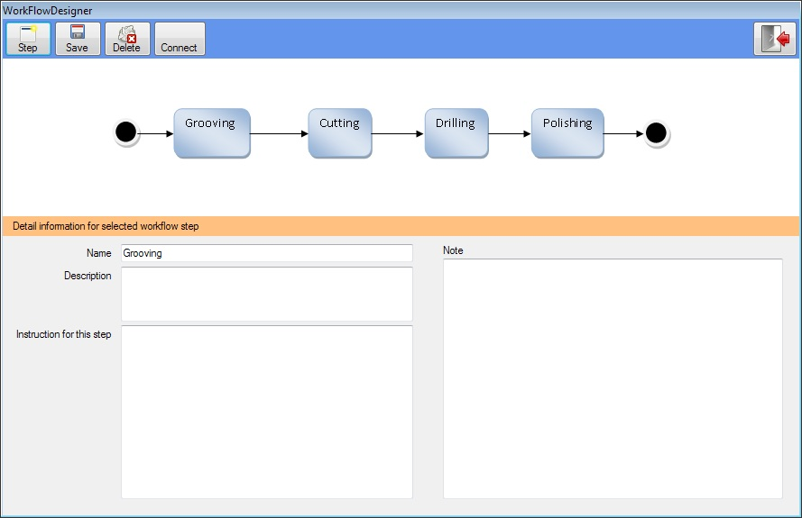

Figure 3.5.2: New Workflow Page

# RESULTS AND FINDINGS

This section describes the key results and findings from the verification of the technical feasibility and usability of the prototype system.

**Technical Feasibility Results**

Based on the created prototype, the project team deems that the proposed architecture for the cylinder management system is feasible. With the proposed logical workflow, the users are able to update the cylinder status using the web user interface. In addition, the users are also able to create cylinder manufacturing steps and assign the steps to form a manufacturing workflow using the thick client user console.

**Usability**

The comments from the users are as follows:

* The proposed GUIs are simple and user friendly.
* The proposed solution submitted by the team.
* The users commented that the proposed user interfaces should follow closely to their current system UI, so that the workers will have less challenges in using the new proposed system.

**Findings**

* The project team has discovered that they could utilise the .Net Entity Framework to reduce the effort in creating the required entity classes. This will reduce a substantial amount of development effort and eventually may shorten the time for development.
* The project team will relook into the current Factory Cylinder Manufacturing UI designs and make the necessary modification for the subsequent UI proposal during the design phase.
* Using the GDI+ library, the developers will be able to drag and drop the created steps icons and form a new cylinder manufacturing workflow. This has solved the initial key technical challenges which the project team had previously faced.
* Some of the developers may need to read up on the .NET C# language to reduce the development challenges which they may face in the implementation stage.
* Based on the prototype implementation effort, the project team deems that they will still be able to complete the software development within the initial planned timeline and therefore no changes will be made to the planned project time schedule.

# CONLUSION

Based on the results and findings documented in section 4, the project team is confident and reassured that their proposed design solution for the cylinder management system will be able to meet the customer’s requirements and is technically feasible.

The proposed architecture design will create a flexible integrated system which would allow users to manage the key manufacturing processes, benchmark employees’ performance, generate daily business operation reports and add in new features to the system if required. In addition, the architecture layout will enable the application components to be reusable and allow exchange of data between different applications or platforms in the future.

Moreover, with the proposed rich client solution for the cylinder workflow management, users will be able to easily drag and drop or create manufacturing steps to produce new cylinder manufacturing workflow processes with ease. In addition, the barcode scanner will also help to quicken the cylinder manufacturing process and shorten the overall cylinder manufacturing time required.

In summary, the customer is satisfied with the proposed solution, and the project team will proceed on to the design phase with the prototype system as a design guideline.